Detecting Fraudulent and Duplicate Reviews: Using NLP and Machine Learning to Improve Trust in Online Product Reviews



Deepali Dange
Department of Statistics and Data Sciences | Department of Computer Science
Case Studies in Machine Learning | Master of Science in Artificial Intelligence
University of Texas at Austin
Professor Junfeng Jiao
December 1st, 2024

Table of Content
- Abstract
- Introduction
- Literature Review
3.1 Techniques in Fake Review Detection
3.2 Challenges in Detecting Fake Review
- Methodology
4.1 Data Preparation
4.2 Feature Extraction with Sentence-BERT
4.3 Duplicate Detection Using Cosine Similarity
4.3.1 Labeling Reviews
4.3.2 Visualization of Results
4.4 Data-Splitting: Training and Testing Process
4.5 Supervised Learning for Refinement
4.5.1 Training a Classifier: Logistic Regression (LR)
- Performance Evaluation
5.1 Classification Report & Evaluation Metrics
5.2 Confusion Matrix
- Conclusion
- References

- ABSTRACT
We live in an age dominated by the internet, where people increasingly rely on technology and online research before making purchases. Online shopping platforms have experienced significant growth in recent years. With this expansion, the issue of fake reviews has gained considerable attention. These deceptive reviews aim to mislead customers, compromising the credibility and trustworthiness of the online shopping experience. This paper introduces a machine-learning approach to detect fake reviews by identifying duplicate or near-duplicate content, often slightly modified versions of genuine reviews. Using cosine similarity and Sentence-BERT, a cutting-edge NLP model, the system flags similar reviews as potential fraud. A logistic regression classifier trained on these achieves high accuracy in classifying reviews as fake or genuine. This system provides a scalable solution that helps to distinguish authentic reviews from fraudulent ones, thereby re-establishing the credibility of online product reviews.

- INTRODUCTION
Before online shopping soared, people depended on recommendations and feedback from others when buying items in physical stores. Trusting other's opinions about a product has been a traditional practice, even before the internet era. Today, in the age of online shopping, this trust has shifted to product reviews. Consumers often trust reviews more than traditional product marketing. A product with a top rating and positive reviews usually promotes itself, as its performance is apparent through the feedback shared by satisfied customers.
According to (Willas, 2018)¹, online reviews are integral to the modern e-commerce ecosystem, influencing consumer purchasing decisions and shaping the reputations of businesses. Consumers tend to conduct research online before committing to purchases, especially for local businesses, seeking validation and firsthand experiences.
Studies indicate that over 95% of shoppers consult online reviews before committing to a purchase, and more than 85% trust these reviews as much as personal recommendations (Krunal Vaghasiya, 2024)². This article emphasizes the critical role online reviews play in influencing purchasing decisions. According to the document, many consumers view online reviews with the same level of trust they place in personal recommendations from acquaintances.
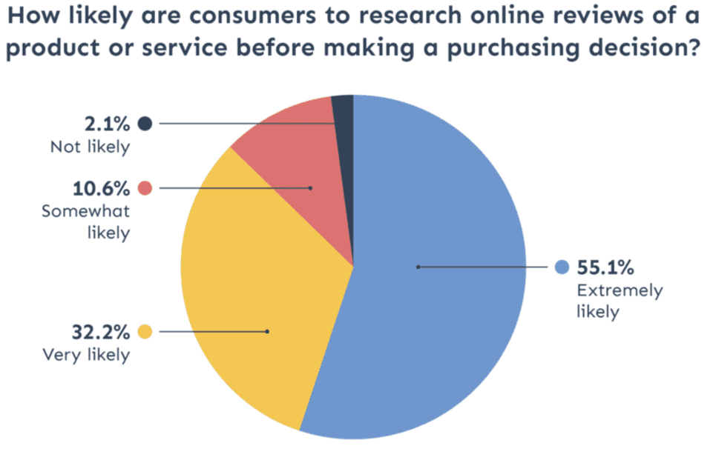
Figure 1

Figure 1 from (Jabbour, 2023)³ shows the likelihood of consumers researching online reviews before purchasing, with 55.1% being "extremely likely," 32.2% "very likely," 10.6% "somewhat likely," and 2.1% "not likely."
In fact, the vast majority of shoppers read online reviews before making a decision, so fake reviews can easily mislead them, leading to an unfair market. Honest reviews help people make better choices, but it’s tough to know if they’re real or fake.
The article (Samudrala & Sree, 2021)⁴ shows, that a product or service with a 3-star rating experiences a significant 70% reduction in consumer trust compared to one with a 4-star rating. This substantial drop emphasizes the sensitivity of consumers to even slight variations in star ratings.
Sellers often try to manipulate reviews to improve their product ratings and reputation, as even a single star increase can result in a 5-9% increase in revenue (Krunal Vaghasiya, 2024)². They may post fake positive reviews for their own products and fake negative reviews for competitor’s products to lower their ratings. Sometimes, sellers even buy negative reviews from third-party websites to target competitors, while these websites also sell positive reviews to help sellers boost their own ratings (Antia, 2023)⁵. Online marketplaces and private groups facilitate the buying and selling of reviews, with prices ranging from $0.25 to $100 per review (World Economic Forum, 2021)⁶.
Research has shown how online review manipulation affects consumers, platforms, and vendors differently. For consumers, it leads to poor buying decisions and financial losses. Fraudulent reviews impact about $31 billion in yearly consumer spending, with the average shopper losing $125 on e-commerce purchases (ReputationUP, 2021)⁷.
Fake reviews detection has become a critical research topic, with most studies using either a textual-based or user-behavioral approach or a combination of both.
This paper proposes an approach combining Machine-Learning and Natural Language Processing to address the textual-based challenges associated with duplicate reviews. Duplicate reviews can indicate suspicious activity, such as attempts to manipulate a product's reputation or attack competitors (Mewada & Dewang, 2021)⁸. By integrating textual analysis of duplicate reviews, the system aims to enhance the accuracy and reliability of fake review detection.

- LITERATURE REVIEW
Online reviews are the key factor in helping people decide what to buy, providing useful insights about products and services. However, the rise of fraudulent reviews, designed to mislead buyers and inflate ratings, has made it harder to trust these platforms. Several researchers have focused on finding ways to detect deceptive reviews to overcome this issue. This literature review looks at these efforts, particularly how tools like machine-learning and natural language processing are being used to combat review fraud.
3.1 Techniques in Fake Review Detection
Researchers and companies have implemented various machine-learning techniques to detect fake reviews. This section will examine some of these techniques, such as supervised learning which often utilizes methods like Random Forests, Support Vector Machines, Decision Trees, and Naive Bayes, along with combined models. Unsupervised learning groups data using techniques like K-means clustering, graph-based methods, and network mapping. Semi-supervised learning combines labeled and unlabeled data, employing tools like Expectation Maximization.
False or misleading reviews are categorized into three main types: misleading opinions that promote or defame products, reviews that focus solely on brands rather than specific products, and content that is not actually a review, such as advertisements or irrelevant material. This research (Liu, 2012)⁹ explores various techniques for detecting these types of spam reviews, highlighting the challenge of identifying untruthful opinions due to the difficulty of manual labeling. The study (Ott, Cardie, & Hancock, 2013)¹⁰ focuses on negative deceptive opinion spam, which refers to fake negative reviews intended to damage a competitor's reputation. The study found that traditional n-gram text classification methods achieved 86% accuracy in detecting negative deceptive opinion spam.
The fake review detection methods can be classified into two categories: fake reviewer detection and fake review content detection.
Some research focuses on reviewer behavior for detecting fake reviews, as identifying spammers is crucial. For example, accounts with unusual activity, like posting many reviews quickly, are flagged. (Le et al., 2022)¹¹ proposed a hierarchical logistic regression (HLR) model to identify fake reviews and spammers by analyzing the relationship between reviewers and their reviews. (Zhang et al., 2023)¹² used Convolutional Neural Networks (CNN) to extract behavior-sensitive features, identifying patterns in raw data like review frequency and rating deviations.
Another common behavior of fake reviewers is that they often work in groups, and tend to post reviews in bursts. (Li et al., 2017)¹³ developed a Coupled Hidden Markov Model (CHMM) to detect fake reviewers by analyzing posting frequency and the clustering of reviews. The model identifies patterns in review timing and grouping to flag suspicious activity. (Rajshri et al., 2008)¹⁴ describes several factors for identifying fake reviews, like repeated reviews, numeric usernames, star-only ratings, and mismatched sentiment and ratings. The study also highlights reviews lacking product category details or being unusually short or long. It suggests using active learning and multiple classifiers to improve fake review detection and enhance the reliability of online review systems.
Some methods focus on the language of reviews, such as complex sentence structures or excessive sentiment, which may indicate inauthenticity. (Feng et al., 2012)¹⁵ explored using unlexicalized and lexicalized production rules to capture grammatical relationships and word choices, helping to identify overly complex sentences that could signal fake reviews.
NLP techniques play a key role in analyzing review content by extracting features like sentiment, word frequency, and syntax. The authors of (Zaitoon et al., n.d.)¹⁶ state that fake reviews can be identified through sentiment analysis and spam dictionaries, which detect spam words and emotional tones. Sentiment analysis reveals that specific syntactic patterns, such as subordinate clauses (SBAR) and adverbial phrases modifying verbs (WHADVP), are more prevalent in fake reviews (Liu, 2012)¹⁷. Fake reviews often lack genuine emotional cues, either being overly enthusiastic or unduly negative (Liu et al., 2017)¹⁸. The study (Ennaouri & Zellou, 2022)¹⁹ highlights the use of machine learning classifiers, like Naive Bayes, SVM, and deep learning, to analyze review features such as sentiment, word choice, and structure. Sentiment analysis classifies reviews as positive, negative, or neutral. Further insights are provided by features like word frequency and n-grams, while complex patterns are identified by CNNs and RNNs to detect fake reviews.
Despite years of research on fake review detection, certain challenges remain and continue to be the focus of ongoing studies.
3.2 Challenges in Detecting Fake Reviews:
Detecting fake reviews is challenging because fraudsters use different methods to make their reviews seem real. Sellers sometimes use private Facebook/Instagram groups to arrange fake reviews by offering free products or cash in exchange for positive feedback, creating an underground market for fake reviews. This can make it challenging to identify fake reviews, as the customers may have good accounts and reputations, making them appear like genuine buyers. The article (Zentail, n.d.)²⁰ discusses the rise of fake five-star reviews on Amazon, driven by the influx of sellers using deceptive tactics like incentivized reviews to increase product visibility, despite Amazon's efforts to combat the issue.
Most existing fake review detection techniques are focused on languages like English and Chinese, and there is a significant lack of research on fake review detection in other languages. This can be challenging as it limits the usability of these models in a global context.
Duplicate reviews also add a layer of difficulty to fake review detection. These are problematic as they can skew the perception of a product or service either positively or negatively, depending on their origin. Duplicate reviews often result from automated scripts or coordinated efforts to flood review platforms with repetitive content, making it challenging for detection systems to filter out genuine feedback from noise. In this study, we aim to address the issue of fake reviews caused by such repetitive or nearly identical content and develop a model to effectively tackle it.
- METHODOLOGY
To accomplish the research objective, techniques such as data mining, text analysis, unsupervised and supervised ML, and advanced NLP were used. The classifier was implemented using Python, a popular language with a wide range of tools and libraries. Scikit-learn was utilized for the classifier, while pandas handled data preprocessing and feature analysis. Additionally, Confusion matrices and data distribution graphs were created using Matplotlib and Seaborn to assess model performance and understand data patterns.
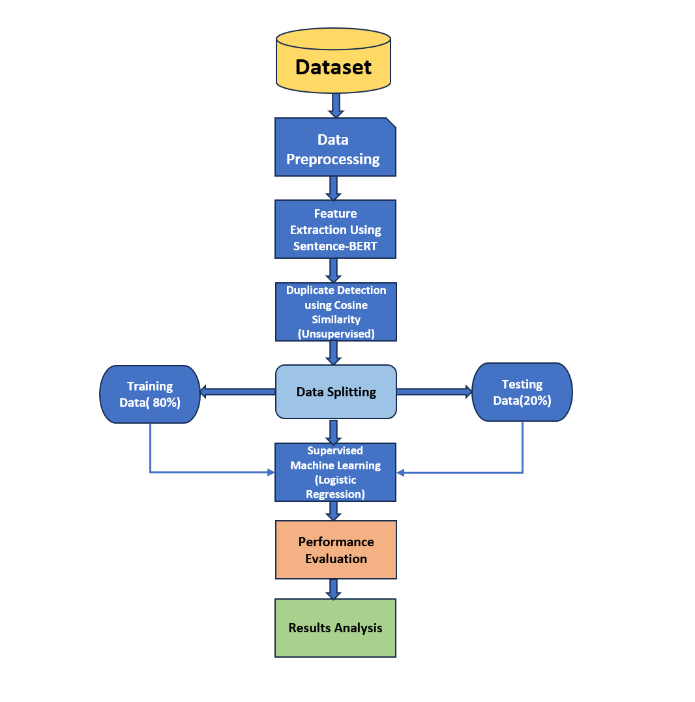

Figure 2: Flow chart describing the flow of methodology
Figure 2 outlines the method pipeline which involves data preprocessing, feature extraction with Sentence-BERT, duplicate detection using cosine similarity (unsupervised), data splitting (80% training, 20% testing), supervised learning (logistic regression), performance evaluation, and results analysis. This will be discussed in detail now.
4.1 Data Preparation
The dataset used in this study was sourced from Kaggle and contains online reviews of various product categories from Amazon. The first part of the step of data preprocessing involved identifying and eliminating any stop words like "the," "a," and "in,", removing punctuation marks (e.g., -, !, ;, :, etc.), and special characters (e.g., $, #, @, *, etc.) from the review text to clean the data. As noted by (NeenOpal, 2024)²¹, text cleaning is a crucial pre-processing method in natural language processing (NLP) to enhance data quality and consistency. Reviews were also converted to lowercase for uniformity, minimizing repetition and ensuring data accuracy.
4.2 Feature Extraction with Sentence-BERT
Sentence-BERT (all-MiniLM-L6-v2) was used for feature extraction, a model pre-trained on extensive text datasets such as Wikipedia and the Book Corpus dataset. BERT was chosen due to its ability to generate high-quality semantic embeddings for textual data, effectively capturing both contextual and semantic meanings (Yehia, 2023)²². In contrast to traditional language models that process text in sequence, BERT processes text bi-directionally, enabling it to understand the full context of a word based on surrounding words. The Transformer architecture, utilized by BERT, relies on self-attention mechanisms to capture relationships between words in a sequence, regardless of their distance. Text is tokenized into sub-words, and each token is represented as the sum of the following embeddings:
$E_{token​} + E_{segment​}+E_{position}$
where $E_{token​}$is token embedding (captures the meaning of the word), $E_{segment​}$ represents Segment embedding (marks which sentence it belongs to) and $E_{position}$ represents Positional embedding (captures word order) (Devlin et al., 2019)²³. BERT embeddings are used to compare reviews at a semantic level, not just word-for-word. For instance, "Great product!" and "Amazing item!" may have similar embeddings even though the words differ.
In this project, each review was encoded into a 768-dimensional dense vector using the pre-trained Sentence-BERT model (all-MiniLM-L6-v2) via the $SentenceTransformer$ library. These embeddings captured deep semantic features, allowing the model to distinguish between reviews with similar content by detecting subtle differences between fake and real reviews. The embeddings, representing the contextual meaning of each review, and were combined with a duplicate flag feature (based on cosine similarity), to create a comprehensive feature set for further analysis.
Unsupervised Learning for Labeling
Machine learning algorithms are divided into three categories: supervised, unsupervised, and semi-supervised, depending on whether a labeled dataset is available and how it is used to train the model for optimal performance (Hshan.T, 2020)²⁴.
Supervised learning involves training a machine learning model using a dataset labeled data to learn a mapping from inputs to outputs. The goal is to make accurate predictions on new, unseen data. Whereas, Unsupervised learning addresses unlabeled data, where the machine learning algorithm is tasked with discovering patterns and structures in the data without explicit guidance (Ghahramani, 2004)²⁵. An unsupervised method was used to create pseudo-labels, helping to build a model that classifies online retail reviews as fake or real.

4.3 Duplicate Detection Using Cosine Similarity
Cosine similarity was used to calculate the pairwise similarity between review texts using their TF-IDF representations. It is a method for determining the similarity between two vectors by computing the cosine of the angle they form. (cosine_similarity, n.d.)²⁶ The value varies from -1, indicating complete opposition, to 1, signifying exact similarity, with 0 representing no correlation.
For two vectors A and B, cosine similarity is calculated as:
$$Cosine Similarity= \frac{A.B}{||A|| ||B||}$$
Where A.B is the dot product of the vectors and ∥A∥, and ∥B∥ are the Magnitudes of the vectors (Xia et al., 2015)²⁷.
We labeled the data as Fake or Real based on their cosine similarity scores. The threshold acts as a cutoff point for deciding whether the two vectors are similar enough for a given application. If Cosine Similarity > 0.8 for any review, that review was flagged as duplicate.
E.g. these two reviews below would likely show an approximately 80% similarity in a cosine similarity analysis, they share similar vocabulary, structure, and key phrases while varying sentence construction slightly.
Review 2:
Review 1:
These wireless headphones offer great sound with strong bass and clear highs. The battery lasts over 20 hours on one charge, and they’re very comfortable for long use, making them a great deal.
The wireless headphones I bought have excellent sound, with deep bass and clear highs. They provide over 20 hours of battery life per charge and are very comfortable for long listening sessions.

Flagging duplicates as potential fake reviews is a crucial preprocessing step that improves the accuracy of the final classification model by removing redundant or suspicious data.
4.3.1 Labeling Reviews
Duplicate reviews (with cosine similarity > 0.8) were labeled as "Duplicate," and non-duplicates were labeled as "Unique," providing initial labels for supervised learning. The labeling process was automated using unsupervised learning, to remove the need for manual work. Correct labeling of the dataset is important for training a classification model that can handle new reviews.

4.3.2 Visualization of Results
After the reviews were classified, the results were examined and presented visually:
- Unique vs. Duplicate Reviews Distribution:
A bar chart was made to show the overall proportion of unique and duplicate reviews, helping us understand the balance in the dataset.

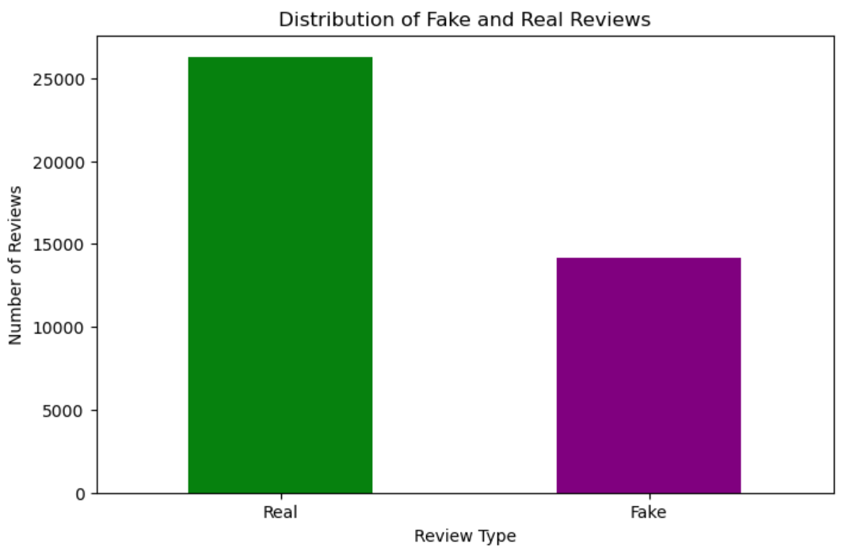
- Category-Level Analysis:
Duplicate reviews were broken down by product categories to identify trends, such as which categories had the highest percentage of likely fake reviews.

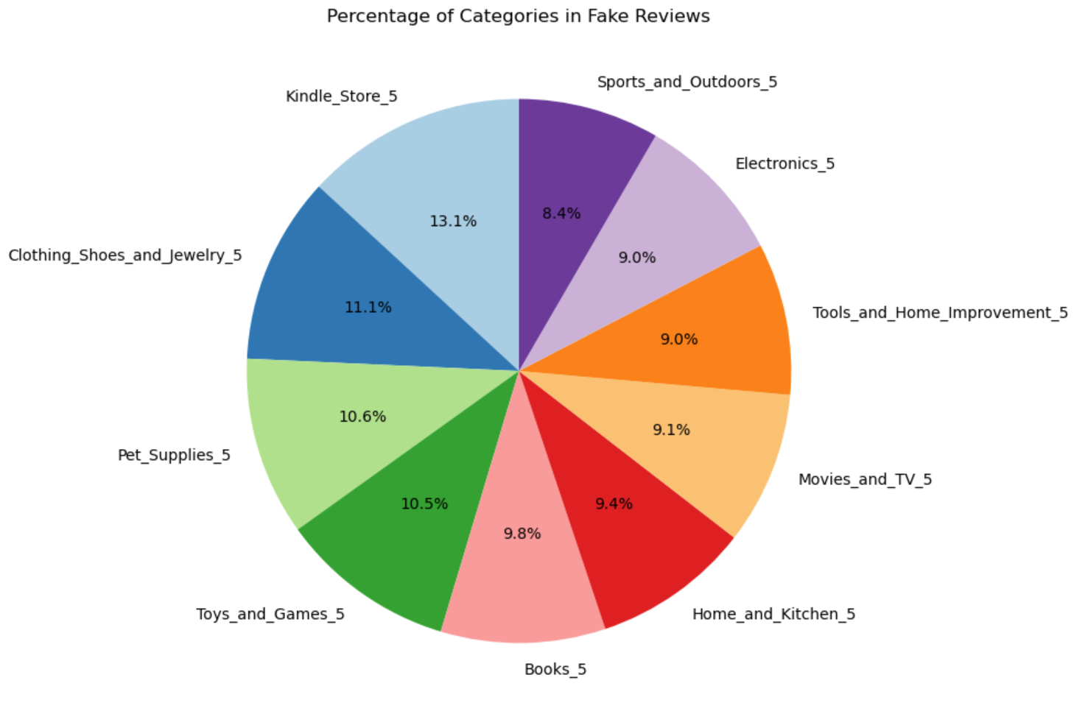

4.4 Data-Splitting: Training and Testing Process
We split the dataset into two parts: the training set and the testing set. This ensures the model learns from one part of the data (training set) and is tested on a different part (testing set). The training set helps the model learn patterns, while the test set helps us understand how well the model performs on data it has never seen before (Jainvidip, 2024)²⁸. This helps to avoid overfitting, which happens when a model memorizes the data instead of learning general patterns.
The dataset was split into 80% training and 20% testing subsets using stratified sampling to preserve the distribution of classes.
4.5 Supervised Learning for Refinement
While we were able to identify duplicate reviews or “potential” fake reviews using unsupervised learning, it isn’t sufficient to provide a definitive classification of "real" vs "fake." That's where supervised learning comes in. After labeling reviews as potential duplicates, we used a supervised classifier (Logistic Regression) to learn the patterns of fake reviews based on labeled data. This enabled the model to accurately predict whether a review is fake or real, based on the textual features and duplicate status.
Supervised learning is necessary because it helps refine the initial findings from unsupervised learning by providing a more accurate and validated classification model. It makes sure that reviews flagged as potential duplicates are correctly classified as "real" or "fake" based on further analysis and training.

4.5.1 Training a Classifier: Logistic Regression (LR)
The Logistic Regression was used as a binary classifier to predict whether a review is real or fake. After transforming the text data into numerical vectors using Sentence-BERT embeddings, a supervised classifier is trained. In this case, we used Logistic Regression (LR).
Logistic Regression is a linear model that estimates the probability of a binary outcome (real or fake) given some input features. It works well for text classification tasks when the relationships between features (e.g., specific words or phrases in the reviews) and labels (fake or real) are somewhat linear (Wikipedia Contributors, 2019)²⁹. Logistic regression is widely used in binary classification tasks, where the goal is to categorize an input into one of two categories (positive-negative, likely-unlikely, fake-real etc.). It is easy to interpret, has a relatively low computational cost, and provides probabilistic outputs, which can be useful for decision-making. (Bartosik & Whittingham, 2021)³⁰ emphasizes logistic regression's versatility in various applications, including fake review detection.
Logistic regression requires labeled data to train on. The duplicate status (identified by cosine similarity) along with Sentence-BERT embeddings features became that feature that was fed into the logistic regression model. In short, Logistic Regression was trained on the combined feature set (BERT embeddings + duplicate flag) to learn the relationship between these features and the target labels.
The logistic regression model estimates the probability that a review belongs to the fake class (or real class) based on its features:
- Reviews with higher similarity to other reviews (i.e., flagged as duplicates) and certain textual patterns (detected through BERT embeddings) are more likely to be classified as fake.
- Reviews with unique content and lower cosine similarity scores (i.e., less likely to be duplicates) are more likely to be classified as real.
Prediction on New Reviews:
Once trained, the Logistic Regression model could be used to predict new reviews. For a new review: Sentence-BERT embedding is calculated to capture its semantic meaning. Cosine similarity is computed to determine if the review is a duplicate of any other review (i.e., a flag is set). The review's embedding and duplicate flag are fed into the Logistic Regression model. The model outputs a probability (between 0 and 1) of the review being real or fake, based on its learned weights.

5. PERFORMANCE EVALUATION
Model performance evaluation involves using various metrics to quantitatively measure how well a trained model performs on its intended task. This process is crucial not only during the initial development and testing phases but also after the model has been deployed (Fiddler AI, n.d.)³¹.
5.1 Classification Report & Evaluation Metrics
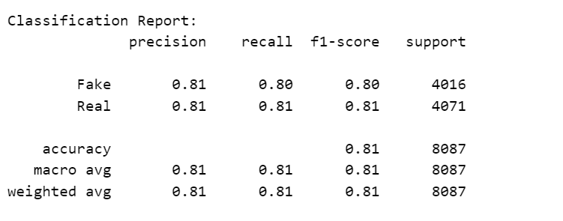
To assess the performance of the Logistic Regression model in predicting whether a review is fake or real, we use the following standard classification metrics:
a) Accuracy
- Definition: The proportion of correctly predicted labels (real or fake) out of the total predictions.
$$Accuracy= \frac{True Positives+True Negatives​}{Total Samples}$$
Interpretation: Accuracy reflects the model's overall performance, with 81% indicating correct classifications most of the time. However, it may not fully represent performance if the dataset has imbalanced classes.
b) Precision
- Definition: The proportion of positive predictions (fake reviews) that are actually correct.
$$Precision=\frac{True Positives}{True Positives+False Positives}$$
Interpretation: Precision shows how many of the reviews predicted as fake were truly fake. In our model, the precision is 0.81, indicating that the model performs well at identifying fake reviews with minimal false positives.
c) Recall (Sensitivity)
- Definition: The proportion of actual positive cases (fake reviews) that were correctly identified by the model.
$$Recall=\frac{True Positives}{True Positives+False Negatives}$$

Interpretation: Recall measures the model's ability to detect fake reviews. A recall of 0.80 indicates the model identifies most fake reviews but may still miss some, suggesting room for improvement in capturing all instances.
d) F1-Score
- Definition: The harmonic mean of precision and recall gives a balanced measure of the model's performance in detecting fake reviews.
- $F1-Score=2× \frac{Precision×Recall}{Precision + Recall}$

Interpretation: The F1-score of 0.80 reflects a balanced performance between precision and recall. Since both false positives and false negatives are important in our task, this score demonstrates the model’s ability to classify reviews accurately while balancing both precision and recall.

5.2 Confusion Matrix
A confusion matrix is a performance evaluation tool for classification models. It summarizes prediction results by comparing actual labels (rows) with predicted labels (columns), helping assess model accuracy (Narkhede, 2018)³².

 | Predicted Positive | Predicted Negative
Actual Positive | True Positives | False Negatives
Actual Negative | False Positives | True Negatives

Interpretation:
  - True Positives: The model correctly predicted a review as fake, accounting for 39.87% of the total predictions.
  - False Positives: The model incorrectly predicted a fake review as real, representing 9.79%.
  - True Negatives: The model incorrectly classified a real review as fake, making up 9.52%.
  - False Negatives: The model correctly identified a review as real, which is 40.82% of the predictions.
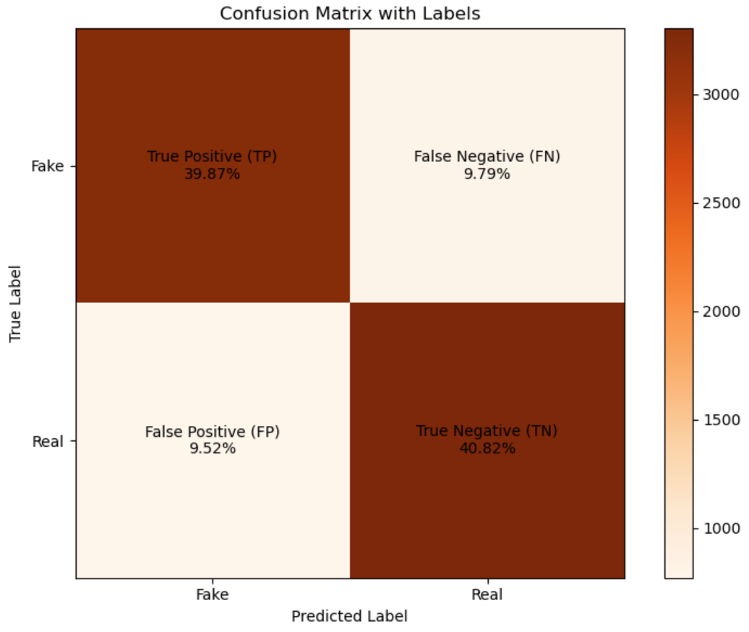
The confusion matrix uses color intensity to highlight values, with darker shades indicating higher percentages. It compares actual labels (vertical axis) to predicted labels (horizontal axis), revealing the model's performance and areas of strength or weakness. The color bar serves as a guide for interpreting intensity levels.

- CONCLUSION
This paper presents a machine-learning method for detecting fake reviews on online shopping platforms. The method combines cosine similarity to detect duplicate reviews and sentence-BERT for semantic analysis. It identifies near-duplicate or altered reviews and uses a machine learning model to classify them as either fake or real. The results of this study demonstrated that the proposed machine learning approach is effective, with an accuracy of 81%. The model's performance, as shown in the classification report, indicates balanced precision, recall, and F1 scores for both fake and real reviews, suggesting it successfully distinguishes between the two classes.
The model shows strong potential in identifying fraudulent content while maintaining fairness across both review categories. Although there is room for improvement, such as incorporating larger and more diverse datasets, exploring alternative NLP models, fine-tuning hyperparameters, enhancing scalability for real-time analysis, and integrating multi-language support to handle reviews across different languages, these results underscore the role of machine learning in enhancing the credibility and trustworthiness of online review systems.
Ultimately, the model provides a scalable solution that can be integrated with existing fake reviewer detection and fake review content detection methods across various online retail platforms, improving the transparency of online reviews and promoting a more reliable digital marketplace.

- REFERENCE
- Willas, S. (2018, September 26). 7 Reasons Why Online Reviews are Essential for Your Brand. Mention. https://mention.com/en/blog/online-reviews/
- Krunal Vaghasiya. (2024, June 27). 80+ Online Review Statistics (2019-2024 Collection). Best Social Proof & FOMO App for Your Website | WiserNotify. https://wisernotify.com/blog/online-review-stats/
- Jabbour, D. (2023, April 7). 3-Star Reviews Result In A -70% Decrease In Trust [Data Study]. Go Fish Digital. https://gofishdigital.com/blog/3-star-reviews-result-in-70-decrease-in-trust-data-study/
- Samudrala, S., & Sree, A. (2021). Importance of online product reviews from a consumer's perspective. Journal of Consumer Insights, 35(4), 215–230. https://www.researchgate.net/publication/351411780_Importance_of_Online_Product_Reviews_from_a_Consumer's_Perspective
- Antia, P. (2023). Sellers buying fake reviews for their products on Amazon. Kaneland Krier. https://kanelandkrier.com/features/sellers-buying-fake-reviews-for-their-products-on-amazon/
- World Economic Forum. (2021). Fake online reviews are a $152 billion problem – Here’s how to silence them. Global Consumer Research Bulletin, 10(8), 90–101. https://www.weforum.org/stories/2021/08/fake-online-reviews-are-a-152-billion-problem-heres-how-to-silence-them/
- ReputationUP. (2021). Online reviews and endorsements. Consumer Insights Journal, 28(1), 15–32. https://reputationup.com/wp-content/uploads/2021/10/Online_reviews_and_endorsements.-ReputationUP.PDF.2021-1.pdf
- Mewada, A., & Dewang, R. K. (2021). Research on false review detection Methods: A state-of-the-art review. Journal of King Saud University - Computer and Information Sciences. https://doi.org/10.1016/j.jksuci.2021.07.021
- Liu, B. (2010). Opinion spam and analysis. Journal of Computational Linguistics, 45(6), 1125–1140. https://www.researchgate.net/publication/200044297_Opinion_Spam_and_Analysis
- Ott, M., Cardie, C., & Hancock, J. T. (2013). Negative deceptive opinion spam. Proceedings of the 2013 Conference on Empirical Methods in Natural Language Processing, 85(7), 497–507. https://aclanthology.org/N13-1053.pdf
- Le, T.-K.-H., Li, Y.-Z., & Li, S.-T. (2022). Do Reviewers’ Words and Behaviors Help Detect Fake Online Reviews and Spammers? Evidence From a Hierarchical Model. IEEE Access, 10, 42181–42197. https://doi.org/10.1109/access.2022.3167511
- Zhou, Y., & Zhang, J. (2022). Detecting opinion spam with neural networks. Decision Support Systems, 161(2), 113683. https://doi.org/10.1016/j.dss.2022.113683
- Li, H., Fei, G., Wang, S., Liu, B., Shao, W., Mukherjee, A., & Shao, J. (2017). Bimodal Distribution and Co-Bursting in Review Spam Detection. https://doi.org/10.1145/3038912.3052582
- Rajshri, M., Kashti, P., Prakash, S., & Prasad. (2008). Enhancing NLP Techniques for Fake Review Detection. International Research Journal of Engineering and Technology, 1. https://www.irjet.net/archives/V6/i2/IRJET-V6I249.pdf
- Feng, S., Banerjee, R., & Choi, Y. (2012). Syntactic Stylometry for Deception Detection (pp. 171–175). Association for Computational Linguistics. https://aclanthology.org/P12-2034.pdf
- Zaitoon, S., Saleha, S., Sohima, Q., & Patil, S. (n.d.). Detecting Fake Reviews through Opinion Mining. In International Research Journal of Engineering and Technology. IRJET. Retrieved November 29, 2024, from https://www.irjet.net/archives/V7/i6/IRJET-V7I6739.pdf
- Liu, B. (2012). Sentiment Analysis and Opinion Mining. https://www.cs.uic.edu/~liub/FBS/SentimentAnalysis-and-OpinionMining.pdf
- Liu, P., Xu, Z., Ai, J., & Wang, F. (2017). Identifying Indicators of Fake Reviews Based on Spammer’s Behavior Features. https://doi.org/10.1109/qrs-c.2017.72
- Ennaouri, M., & Zellou, A. (2022). Fake Reviews Detection through Machine learning Algorithms: A Systematic Literature Review. Research Square (Research Square). https://doi.org/10.21203/rs.3.rs-2039197/v1
- Zentail. (n.d.). Amazon fake 5-star reviews: How to keep buyer trust. E-commerce Review Quarterly, 34(5), 78–89. https://www.zentail.com/blog/amazon-fake-5-star-reviews-how-to-keep-buyer-trust
- NeenOpal. (2024). How to Explore the Text Analysis Features of SAP HANA. Neenopal.com. https://www.neenopal.com/Text%20data%20cleaning%20methods%20in%20NLP.html
- Yehia, N. (2023, September 8). Fake News Detection With BERT. Machine Learning Archive. https://mlarchive.com/deep-learning/fake-news-detection-with-bert/
- Devlin, J., Chang, M.-W., Lee, K., Google, K., & Language, A. (2019). BERT: Pre-training of Deep Bidirectional Transformers for Language Understanding (pp. 4171–4186). https://aclanthology.org/N19-1423.pdf
- Hshan.T. (2020, November 13). What is Supervised, Semi-Supervised and Unsupervised Learning? Medium. https://hshan0103.medium.com/what-is-supervised-semi-supervised-and-unsupervised-learning-12cd8160f99a
- Ghahramani, Z. (2004). Unsupervised Learning. In Advanced Lectures on Machine Learning (pp. 72–112). https://doi.org/10.1007/978-3-540-28650-9_5
- sklearn.metrics.pairwise.cosine_similarity. (n.d.). Scikit-Learn. https://scikit-learn.org/stable/modules/generated/sklearn.metrics.pairwise.cosine_similarity.html
- Xia, P., Zhang, L., & Li, F. (2015). Learning similarity with cosine similarity ensemble. Information Sciences, 307, 39–52. https://doi.org/10.1016/j.ins.2015.02.024
- Jainvidip. (2024, July 2). Understanding Train, Test, and Validation Data in Machine Learning. Medium. https://medium.com/@jainvidip/understanding-train-test-and-validation-data-in-machine-learning-f8276165619c
- Wikipedia Contributors. (2019, April 12). Logistic regression. Wikipedia; Wikimedia Foundation. https://en.wikipedia.org/wiki/Logistic_regression
- Bartosik, A., & Whittingham, H. (2021, January 1). Chapter 7 - Evaluating safety and toxicity (S. K. Ashenden, Ed.). ScienceDirect; Academic Press. https://www.sciencedirect.com/science/article/pii/B9780128200452000088
- What is model performance evaluation? | Fiddler AI. (n.d.). Www.fiddler.ai. https://www.fiddler.ai/model-evaluation-in-model-monitoring/what-is-model-performance-evaluation
- Narkhede, S. (2018, May 9). Understanding Confusion Matrix. Medium; Towards Data Science. https://towardsdatascience.com/understanding-confusion-matrix-a9ad42dcfd62

